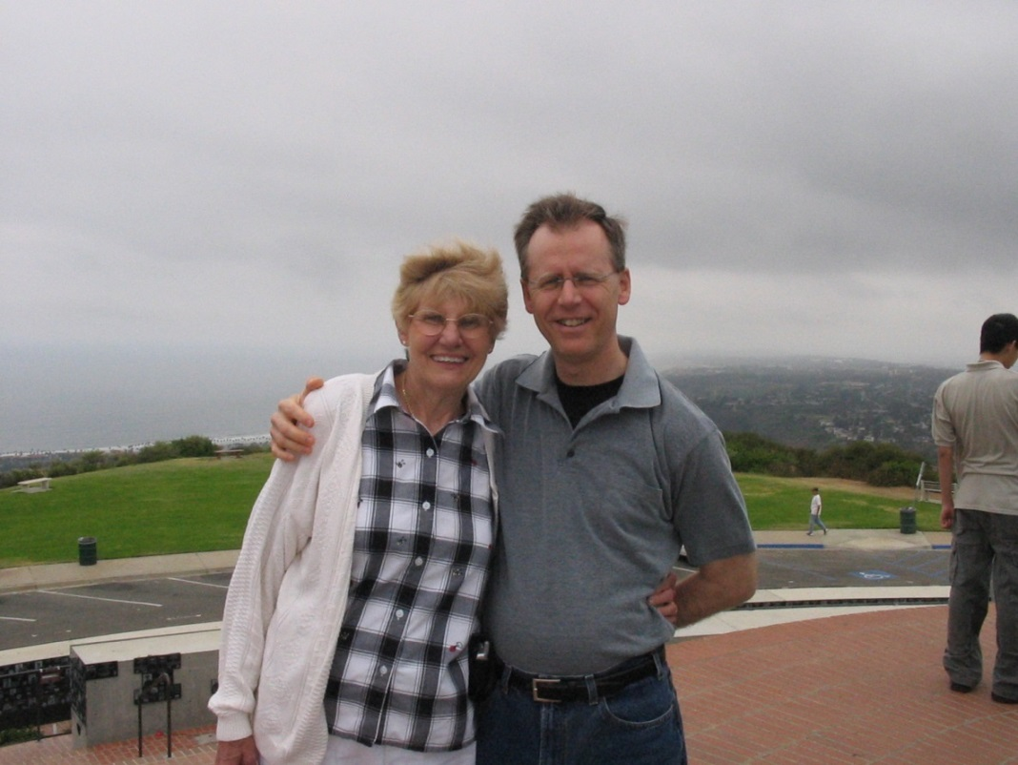

Lois and son, Greg Harrington in San Diego – 2005

|  |  |
| --- | --- |
| C:\Users\Richard\Documents\Family Tree Maker\Book Material - Wolfe\Album Pictures\Daniel Edward Harrington - March 2013.jpg  Daniel Edward Harrington - March 2013 | Kyle Ira Stasikowski Harrington, PhD, and his mother, Margaret Jadwiga Stasikowski  Taken – 15 May 2010 |